Where Does Your Time Go?

Estimate the number of hours you spend each week on the following activities. When you are finished, subtract your total hours from 168, the number of hours in a week. How much time is left? How will you use this time?
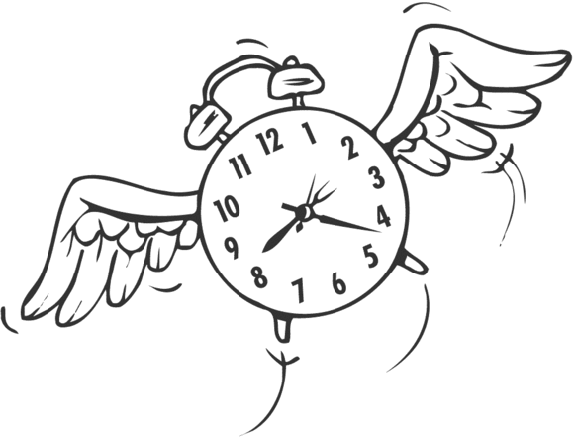
Activity Hours Per Week:

1. Working ____
2. Going to classes ____
3. Sleeping ____
4. Dressing, showering, etc. ____
5. Traveling to and from work, etc. ____
6. Studying ____
7. Eating ____
8. Watching television ____
9. Engaging in sports; other leisure activities ____
10. List any other regular obligations or appointments you must meet during a typical week and the time you spend, for example, at church, at dance, music, or other lessons, at appointments with a tutor, etc.
____________________________________________________
____________________________________________________
____________________________________________________
____________________________________________________
____________________________________________________

TOTAL = _______

168 Hours minus total = _______

Use your time wisely!

